**Question Bank - Functions and Relations**

1. Diagram the following functions and mention whether they are one-to-one, onto or bijective:
   1. f : {a, b, c, d} → {1, 2, 3, 4}

f(a) = 1

f(b) = 2

f(c) = 3

f(d) = 4

* 1. g : {a, b, c, d} → {1, 2, 3, 4}

g(a) = 1

g(b) = 1

g(c) = 4

g(d) = 4

1. Let A = {1, 2, 3, 4} and B = {0, 3, 6, 8, 12, 15}.Consider a rule f (x) = x² - 1, x∈A, then
   1. show that f is a mapping from A to B.
   2. draw the arrow diagram to represent the mapping.
   3. represent the mapping in the roster form.
   4. write the domain and range of the mapping.
2. Find all real values of x such that f(x) = g(x) where f and g are functions given by f(x) = 3x + √(x) and g(x) = 2x + 6.
3. Identify if each of the following is one to one function ,onto function or both.

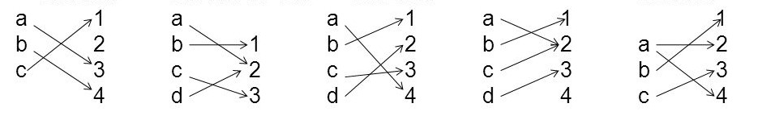

Fig 1 Fig 2 Fig 3 Fig 4 Fig 5

1. For the set A = {1, 2, 3, 4}, show the matrix and digraph representation of the relation R = {(1, 1), (1, 3), (2, 1), (2, 3), (2, 4), (3, 1), (3, 2), (4, 1)}.
2. Let A = {1, 2, 3, 4, 5} and B = {a, b, c, d}. Which of the following arrow diagram(s) defines onto functions? Explain.

|  |  |  |  |  |
| --- | --- | --- | --- | --- |
| Diagram 1 |  | Diagram 2 |  | Diagram 3 |

1. Define functions *f* from **Z** to **Z** and *g* from **R** to **R** by the formulas: for all *y***Z** and*x***R**,

*f*(*y*) = *y*2 and *g*(*x*) = 2*x* + 1

**a**. Is *f* onto? Prove or disprove by giving a counter example.

**b**. Is *g* onto? Prove or disprove by giving a counter example.

1. Given relations on the set A={1,2,3} identify if each of the relations is reflexive,symmetric, and transitive.
   1. R1={(1,1),(2,2),(3,3)}
   2. R2((2,2),(2,3),(3,2))
   3. R3{(2,3),(3,2)}
   4. R4={(1,2),(1,3),(2,3)}
2. Let R be a relation on the set of real numbers such that aRb iff a-b is an integer. Prove whether R is an equivalence relation.
3. Let A = {1, 2, 3, 4} and R = {(1,1), (1,2), (2,1), (2,2), (3,4), (4,3), (3,3), (4,4)} be a relation on A. Verify that R is an equivalence relation.